Multiple-choice section

|  |  |  |  |  |  |  |  |  |
| --- | --- | --- | --- | --- | --- | --- | --- | --- |
| Question | 1 | 2 | 3 | 4 | 5 | 6 | 7 | 8 |
| Answer | C | D | A | D | A | C | A | D |

Question 1 [8.1]

**C**

You can walk around the car park and observe the make of each car.

Question 2 [8.2]

**D**

1, 2, 3, 4, 6, 8

mean =  = 4

median =  = 3.5

Question 3 [8.3]

**A**

 = 24.5

Question 4 [8.5]

**D**

21 beads in all with 5 blue, so there are 16 that are not blue. Pr(not blue) = 

Question 5 [8.5]

**A**

Four 3s have been rolled out of a total of 30 rolls = 



Question 6 [8.6]

**C**

multiples of 4: 4, 8, 12, 16, 20, 24, 28

multiples of 6: 6, 12, 18, 24, 30

12 and 24 are only counted once each to give a total of 10 successful outcomes: 

Question 7 [8.7]

**A**

By drawing a tree diagram, there are 36 possible outcomes, but only one where Sheldon has Korny Kobs two days in a row, which is the one required, so the answer is .

Question 8 [8.7]

**D**

Pr(*A* even and *B* odd) =  = 

Multiple-choice total marks: 8

Short answer section

Question 9 3 marks [8.2, 8.4, 8.7]

**(a)** An event for which the probability is 1 is said to be *certain*.

**(b)** The number of brothers and sisters you have is an example of *discrete data*.

**(c)** If a statistical graph is not symmetrical it is said to be *skewed*.

Question 10 2 marks [8.2]

Every value between 52 kg and 53 kg, for example, could be attained at some point. The values that are written are just rounded values of potentially infinite decimal values.

Question 11 5 marks [8.2]

|  |  |  |  |  |  |  |  |  |
| --- | --- | --- | --- | --- | --- | --- | --- | --- |
| A | *x* | *f* | B | *x* | *f* | C | *x* | *f* |
|  | 30  31  32  33  34 | 3  5  10  5  3 |  | 15  16  17  18  19  20 | 10  15  8  3  1  2 |  | 48  49  50  51  52  53 | 6  5  8  14  20  10 |

**(a)** mean = median for I since the distribution is symmetrical.

**(b)** B and C have the same range:

B: range = 20 – 15 = 5

C: range = 53 – 48 = 5

For A: range = 34 – 30 = 4

**(c)** B has a positive skew (tail to the right).

|  |  |  |
| --- | --- | --- |
| *x* | *f* | *x* × *f* |
| 15  16  17  18  19  20 | 10  15  8  3  1  2 | 150  240  136  54  19  40 |
| Total | 39 | 639 |

mean =  ≈ 16.4; median: 19th datum = 16

Question 12 7 marks [8.3]

**(a)**

|  |  |  |  |
| --- | --- | --- | --- |
| Distance (m) | Frequency | Midpoint | *xf* |
| 0−<10 | 4 | 5 | 20 |
| 10−<20 | 12 | 15 | 180 |
| 20−<30 | 24 | 25 | 600 |
| 30−<40 | 9 | 35 | 315 |
| 40−<50 | 1 | 45 | 45 |
|  | Σ*f* = 50 |  | Σ*xf* = 1160 |

mean =  = 23.2 m

**(b)**

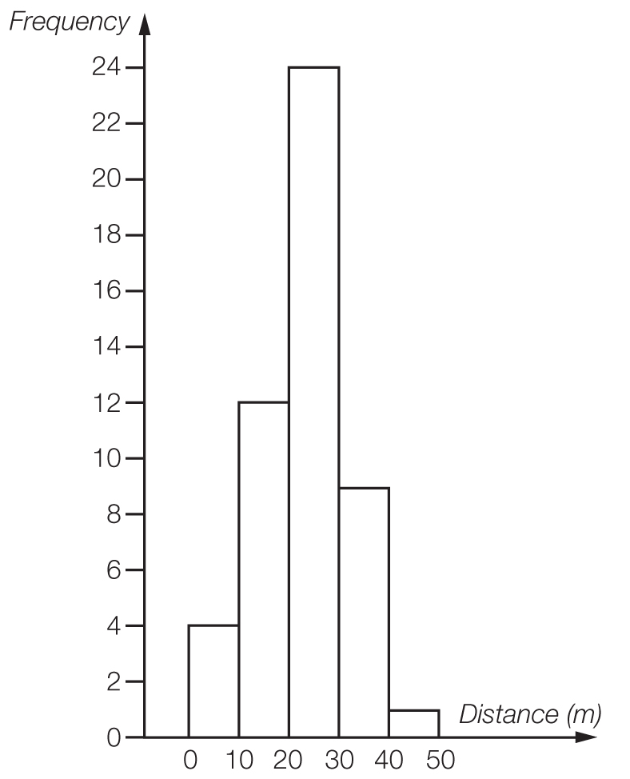

The large number of values in the middle band makes this relatively symmetrical.

Question 13 2 marks [8.5]

**(a)** Pr(Rhonda wins) =  = 40%

**(b)**  × 8 = 4.8

Michelle would expect to win 5 games.

Question 14 3 marks [8.5]

**(a)** Pr(neither red nor pink) =  =  = 

**(b)**  × 8 = 2.5

2 or 3 lollies are expected to be pink or brown.

Question 15 6 marks [8.6]

**(a)**

|  |  |  |  |
| --- | --- | --- | --- |
|  | TV in bedroom | No TV |  |
| Ride bicycle | 2 | 8 | 10 |
| No riding | 5 | 7 | 12 |
|  | 7 | 15 | 22 |

**(b)** **(i)** Pr(TV) = 

**(ii)** Pr(TV and bicycle) =  = 

**(iii)** Pr(no bicycle riding) =  = 

**(c)** Pr(TV knowing bicycle riding) =  = 

Question 16 9 marks [8.6]

**(a)** **(i)** *A* and *B* are mutually exclusive.

**(ii)** *A* and *C* are not mutually exclusive.

**(iii)** *A* and *D* are not mutually exclusive.

**(b)** Complete the Venn diagram by writing all the letters of the alphabet in the correct regions.

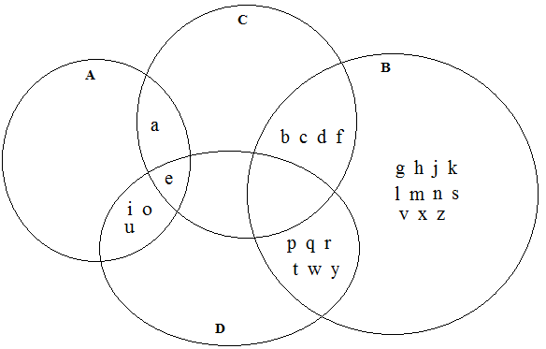

**(c)** **(i)** Pr(*A*) = 

**(ii)** Pr(*B* and *C*) =  = 

**(iii)** Pr(*C* or *D*) = 

**(iv)** Pr(*A* and *B*) = 0

Question 17 8 marks [8.7]

**(a)**

|  |  |  |  |  |  |  |  |  |  |
| --- | --- | --- | --- | --- | --- | --- | --- | --- | --- |
|  | R1 | R2 | R3 | Y1 | Y2 | B1 | B2 | B3 | B4 |
| R1 |  | RR | RR | RY | RY | RB | RB | RB | RB |
| R2 | RR |  | RR | RY | RY | RB | RB | RB | RB |
| R3 | RR | RR |  | RY | RY | RB | RB | RB | RB |
| Y1 | YR | YR | YR |  | YY | YB | YB | YB | YB |
| Y2 | YR | YR | YR | YY |  | YB | YB | YB | YB |
| B1 | BR | BR | BR | BY | BY |  | BB | BB | BB |
| B2 | BR | BR | BR | BY | BY | BB |  | BB | BB |
| B3 | BR | BR | BR | BY | BY | BB | BB |  | BB |
| B4 | BR | BR | BR | BY | BY | BB | BB | BB |  |

**(b)** Pr(RR) = 

**(c)** Pr(RR, YY or BB) = 

**(d)** Pr(neither blue) = 

**(e)** Pr(BY or YB) = 

Question 18 5 marks [8.3]

**(a)** This data set has negative skew as the mean has been pulled to the left.

**(b)** To give a mean of 32 from 16 scores, the total must be 512.

A sample answer: Put 37 and 38 in the middle two positions, to give a median of 37.5. There must be more 41s than any other score.

e.g. 18, 20, 22, 23, 24, 25, 26, 37, 38, 38, 39, 39, 40, 41, 41, 41

Short answer total marks: 50

Extended answer section

Question 19 18 marks [8.4]

**(a)** NSW: mean = ** =** 164.2 cm; Victoria: mean =  = 167.8 cm

**(b)**

|  |  |  |
| --- | --- | --- |
| NSW Year 9 students |  | Victoria Year 9 students |
| 6 | 12H |  |
|  | 13L |  |
|  | 13H |  |
| 2 | 14L |  |
| 8 6 | 14H |  |
| 2 2 0 | 15L |  |
| 6 5 | 15H | 7 9 |
| 4 4 4 2 0 0 | 16L | 0 0 1 1 2 2 4 4 |
| 7 7 6 | 16H | 5 5 5 6 6 7 7 7 7 7 8 |
| 4 4 3 2 0 | 17L | 2 4 4 |
| 9 9 6 5 | 17H | 5 5 7 8 |
| 2 2 | 18L | 2 |
| 8 | 18H | 6 |

**(c)**

|  |  |  |
| --- | --- | --- |
| NSW Year 9 students |  | Victoria Year 9 students |
| 6 | 12 |  |
|  | 13 |  |
| 8 6 2 | 14 |  |
| 6 5 2 2 0 | 15 | 7 9 |
| 7 7 6 4 4 4 2 0 0 | 16 | 0 0 1 1 2 2 4 4 5 5 5 6 6 7 7 7 7 7 8 |
| 9 9 6 5 4 4 3 2 0 | 17 | 2 4 4 5 5 7 8 |
| 8 2 2 | 18 | 2 6 |

**(d)** NSW: median = 165 cm and range = 188 – 126 = 62 cm

Victoria: median = 166.5 cm and range = 186 – 157 = 29 cm

**(e)** Although the mean and median are close for the two different states, the range of heights is quite different. The 9 shortest students come from NSW, as does the tallest student. The second stem plot exaggerates the large modal class for the Victorian students. With raw data available from either stem plot there is no real advantage of choosing one over the other.

**(f)** Estimated mean:  = 166.0 cm

Estimated median: = 166 cm

Range of sample of 60: 188 – 126 = 62 cm so population range is almost certain to be higher, say 70 cm, unless the tallest and shortest Year 9 students in both states just happened to be in this sample. Assume that the samples are random and hence mean and median of samples is the best predictor of population averages. It has been assumed equal numbers of Year 9 students in each state which is unlikely. The limitation is that this will only predict population statistics for the same time of year as the data was gathered as a portion of Year 9 students will grow throughout the year.

Question 20 18 marks [8.3, 8.5]

**(a)** Mean =  ≈ 40.0 runs

0, 0 , 1, 7, 9, 12, 13, 14, 21, 21, 21 | 23, 24, 26, 37, 38, 54, 56, 65, 121, 144, 174

Median = 22 runs

Range = 174 – 0 = 174 runs

**(b)**

|  |  |  |  |
| --- | --- | --- | --- |
| Score range | Frequency | Centre | *xf* |
| 0–19 | 8 | 9.5 | 76 |
| 20–39 | 8 | 29.5 | 236 |
| 40−59 | 2 | 49.5 | 99 |
| 60−79 | 1 | 69.5 | 69.5 |
| 80−99 | 0 | 89.5 | 0 |
| 100−119 | 0 | 109.5 | 0 |
| 120−139 | 1 | 129.5 | 129.5 |
| 140-159 | 1 | 149.5 | 149.5 |
| 160-179 | 1 | 169.5 | 169.5 |
|  | Σ*f* = 22 |  | Σ*xf* = 929 |

Estimate for mean:  ≈ 42.2

**(c)** The estimated mean is 2.2 runs higher, or 48 runs more in total. The larger the set of data, the less significant is the estimating difference likely to be. However, on all occasions the zero and other scores less than 10 will be elevated to 9.5 so a low-scoring batsman would get an estimated score much higher than the accurate value.

**(d)** Pr(score is under 10) =  × 100% ≈ 23%

**(e)** Without scores under 10:

Mean =  ≈ 50.8 runs

**(f)** **(i)** Pr(at least 50) =  × 100% ≈ 27%

**(ii)** Pr(at least 100) =  × 100% ≈ 14%

**(g)** Pr(100 once 50 is reached) =  × 100% = 50%

Extended answer total marks: 37

TOTAL test marks: 95